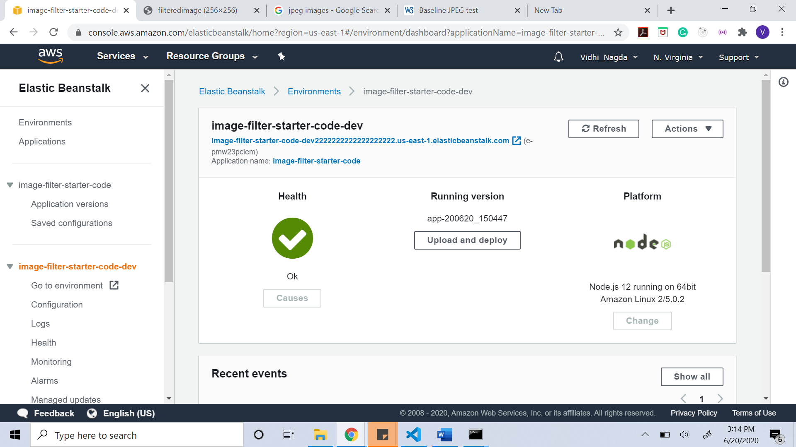

Link to the elastic beanstalk with image query parameter added.

<http://image-filter-starter-code-dev2222222222222222222.us-east-1.elasticbeanstalk.com/filteredimage?image_url=https://www.w3.org/MarkUp/Test/xhtml-print/20050519/tests/jpeg420exif.jpg>

Github Repository: <https://github.com/Vidhi-95/Udagram_UdacityNanoDegree>

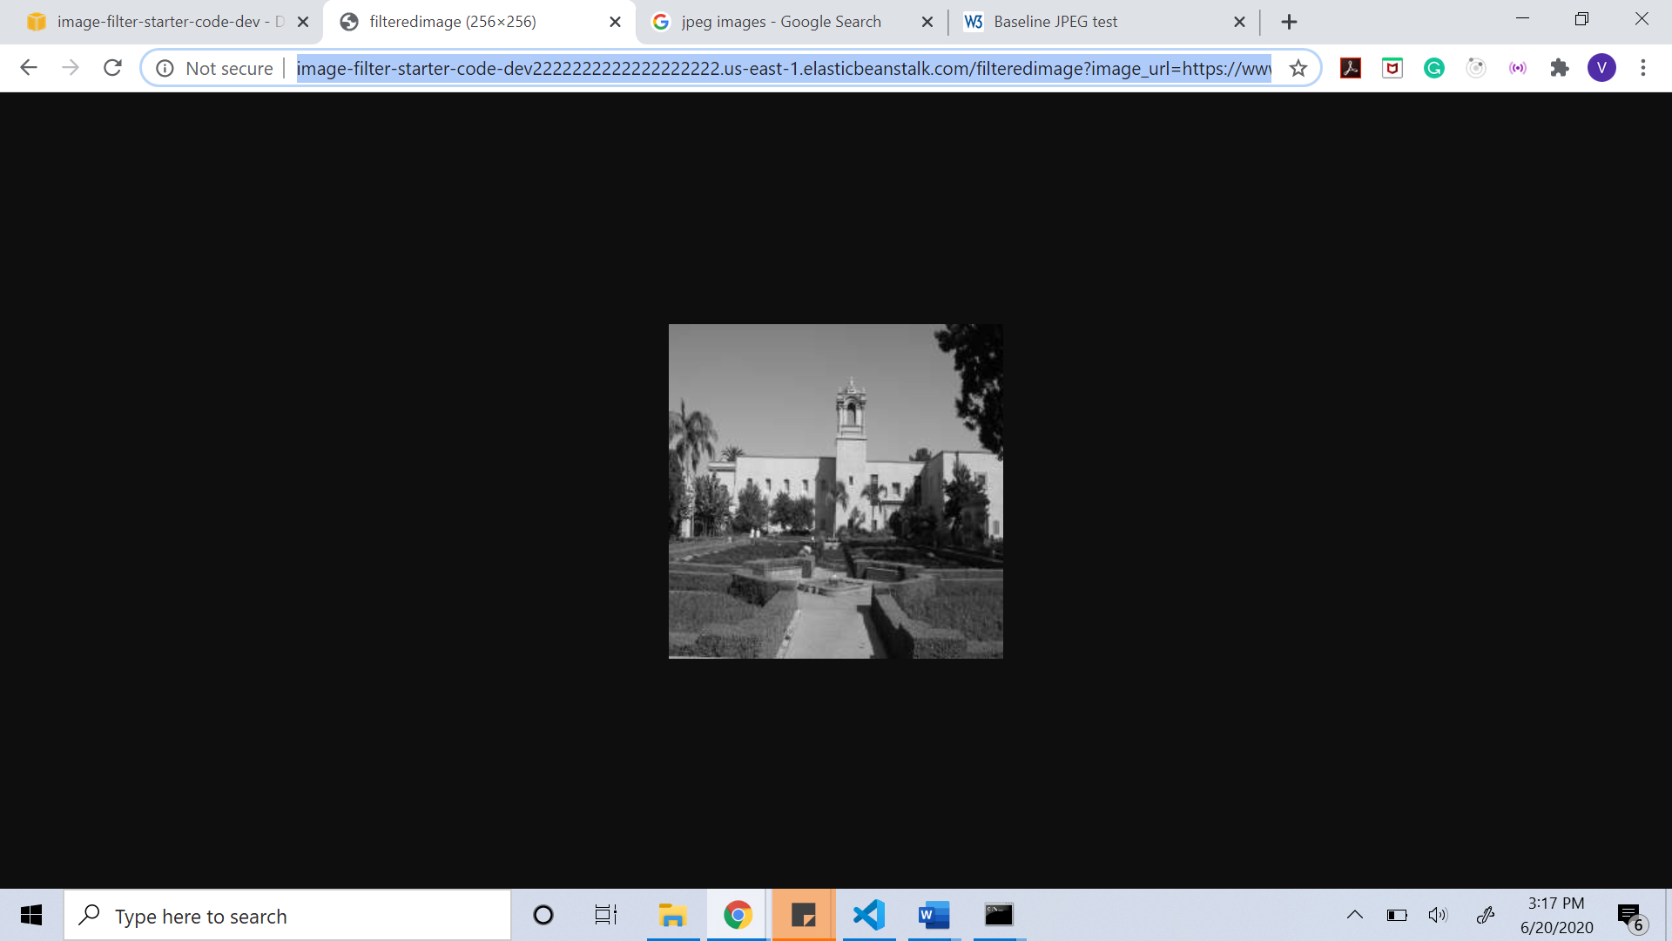

Git hub Repository: https://github.com/Vidhi-95/Udagram_UdacityNanoDegree.git